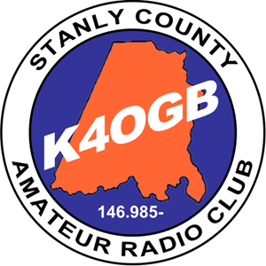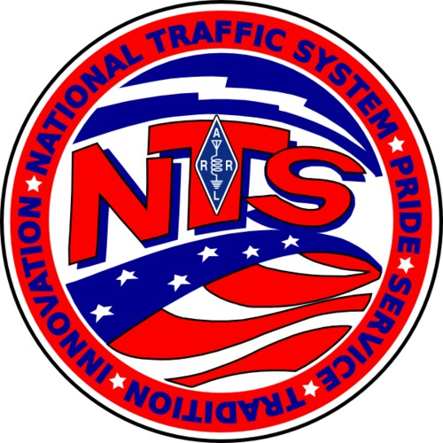
Stanly County Amateur Radio Club: Hams, Traffic and the National Traffic System (NTS) April 22, 2017
Note: All class materials are available at https://www.dropbox.com/sh/2iaxajrlnk2jurf/AAB5g7ozCpvmjV5CR0gUL39Va?dl=0
Intro: What is NTS
Part 1: The Chicken and the Egg: The message and the Net – Hal WB4ZIQ
- What is a message
  - Radiogram
  - ICS-213
- What is a net and why we have them
- How a typical traffic net works
- The NTS and its hierarchy
- The ARRL Net Directory www.arrl.org/nts select ARRL Net Directory Search
Part 2: How to get started – Lane – WK4WC
- The Radiogram form with detailed look at each field and its purpose
- ARL numbered messages (FSD-3)
- Once originated, how to get the message into the system.
- How to pass and receive traffic – specifically on voice nets
- How to deliver traffic to the recipient
Part 3: Digital Ops - Hal
- Modes
- Software tools
- NTS-D (or DTN)
Part 4: Monthly Reporting (to Dave Roy – W4DNA, STM)
- Station Activity Report (SAR)
- Public Service Honor Roll (PSHR)
- NTS-D Report (to WB2FTX, EADC) - RECEIVED 47 SENT 12 TOTAL 59
- Logs and retention

Part 5: ARES - Lane
- ICS Courses 100, 200, 700, 800 – JUST DO IT!
- ICS-213 Form
  - Descriptions of each field and its purpose
  - RRI Modified form
  - How to pass ICS-213
  - Tools
    - RMS Express forms
    - Other software

Part 6: Software Tool: Ready To Copy – Lane
- Demo
- Shortcuts and tricks for easier use.

Part 7: Questions and Answers

Diploma / Wallpaper:
Send email to wb4ziq@arrl.net when you have a monthly SAR total count of 5 for your course certificate.

Additional Resources
www.arrl.org
www.arrl.org/nts
http://www.qsl.net/w/w4eat//w4eat/
https://www.arrl.org/files/file/trainingTrafficHandlersGuide.pdf
http://www.arrl.org/arrl-net-directory
www.training.fema.gov/nims
www.winlink.org
www.qrz.com
http://www.ncarrl.org/nets/index.html

